
Pricing List
20X20 Tent | Tables and/or chairs can be added for cathedral seating or dinner style. Asphalt/Concrete set ups are extra depending on staking/weighting needs. | $400
20X20 Tent Package | 20X20 comes with 4 round tables, 32 fan back chairs  Add-ons available  Max Capacity: 40 Guests | $475
20X30 Tent | Tables and/or chairs can be added for cathedral seating or dinner style. Asphalt/Concrete set ups are extra depending on staking/weighting needs. | $600
20X30 Tent Package | 20X30 comes with 6 round tables 48 fan back chairs.  Add-ons available  Max Campacity: 56 Guests | $675
20X40 Tent | Tables and/or chairs can be added for cathedral seating or dinner style. Asphalt/Concrete set ups are extra depending on staking/weighting needs. | 700
20X40 Tent Package | 20X40 comes with 8 round tables, 64 fan back chairs  Add-ons available  Max Capacity:80 Guests. | $875
63” Round Tables | 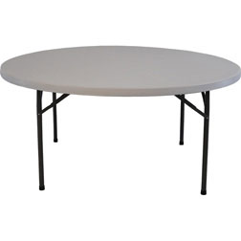  8 fan back chairs fit comfortably at each round table | $20
8 ft banquet table | 8 fan back chairs fit comfortably at each table  Can be used for food or gifts. | $15
6 ft. Banquet table | 6 fan back chairs fit comfortably at each table  Can be used for food or gifts. | $15
Fan Back Chairs | 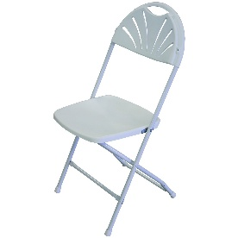  White, foldable | $3
Ice Table | 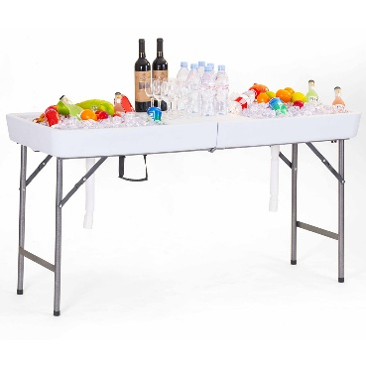  Add ice to fill this table and keep beverages and food cool outdoors | $30
Axe Throwing (plastic) | 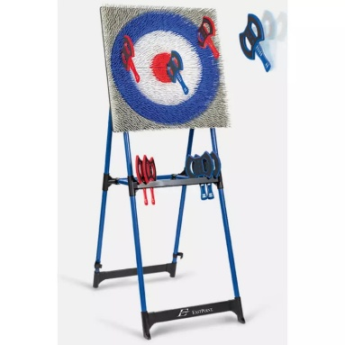  1 currently available | $35
Lights 20X20 | 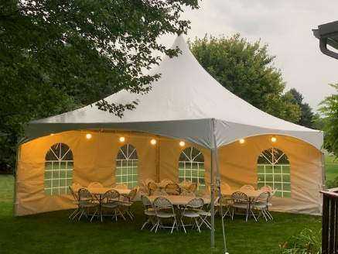  One 20” strand, hung from corner to corner  Globe lighting  Will need renter to provide extension cord and electricity outlet within 100” | $35
Lights 20X30 or 20X40 | Same as above | $55
Make it weather-proof
Tent Side Wall 20’ | Recommended adding 1-2 sides to allow guests to easily enter and leave tent without creating pockets of wind  Note: 40’ side can be set up in 1 or 2 20’ sections (full 40’ will require 2) | $50
Tent Side wall 30’ | Same as above | $55

